Progress, Status, and Management Monthly Report

|  |  |
| --- | --- |
| Contract | FA8730-21-D-0001/FA####-##-X-#### |
| Deliverable Number | XX |
| CDRL | A006 – Progress, Status, and Management (PSM) Report |
| Project Duration | [Start date] – [End Date] |
| GTRI Project Number | DXXXX |
| Project Title | [Title] |
| For period | 1 August 2021 – 31 August 2021 |
| Submitted by | GTRI PD(s) |
| Date Prepared | [Date Prepared] |

|  |  |
| --- | --- |
| Task 1 | Systems Engineering |
| Task 2 | Configuration Management |
| Task 3 | Logistics Management |

# Highlights

| Task # | Description | Benefit to HBG | | |
| --- | --- | --- | --- | --- |
| Time | Cost | Technical |
| 1 | Developed simplified “radar equation” based model that generates similar outputs to TAP model with PHaRLAP HF ray datasets |  |  |  |
| 2 | Presented MBSE Strategy to EN Roundtable. |  |  |  |

# Detailed Performance by Task Reporting

|  |  |
| --- | --- |
| Task 1 | Systems Engineering |

**Activities and Accomplishments for Period**

* .

**Travel for Current Reporting Month**

* .

**Research Goals/Plans for Next Period**

* .

**Issues and Concerns**

* .

|  |  |  |  |
| --- | --- | --- | --- |
| Task Number | Engineering Labor  Category | Number of Individuals | Current Month Total Hours |
| 1 | Principal Research Engineer | 1 | 15 |
| 1 | Senior Research Engineer | 3 | 96 |

|  |  |
| --- | --- |
| Task 2 | Configuration Management |

**Activities and Accomplishments for Period**

* .

**Travel for Current Reporting Month**

* .

**Research Goals/Plans for Next Period**

* .

**Issues and Concerns**

* .

|  |  |  |  |
| --- | --- | --- | --- |
| Task Number | Engineering Labor  Category | Number of Individuals | Current Month Total Hours |
| 2 | Principal Research Scientist | 1 | 48.5 |
| 2 | Principal Research Engineer | 1 | 5 |
| 2 | Senior Research Engineer | 2 | 87 |
| 2 | Research Engineer II | 1 | 74 |
| 2 | Research Engineer I | 3 | 469.9 |

|  |  |
| --- | --- |
| Task 3 | Logistics Management |

**Activities and Accomplishments for Period**

* .

**Travel for Current Reporting Month**

* .

**Research Goals/Plans for Next Period**

* .

**Issues and Concerns**

* .

|  |  |  |  |
| --- | --- | --- | --- |
| Task Number | Engineering Labor  Category | Number of Individuals | Current Month Total Hours |
| 3 | Senior Research Engineer | 1 | 32 |

Cumulative Cost Report for All Tasks

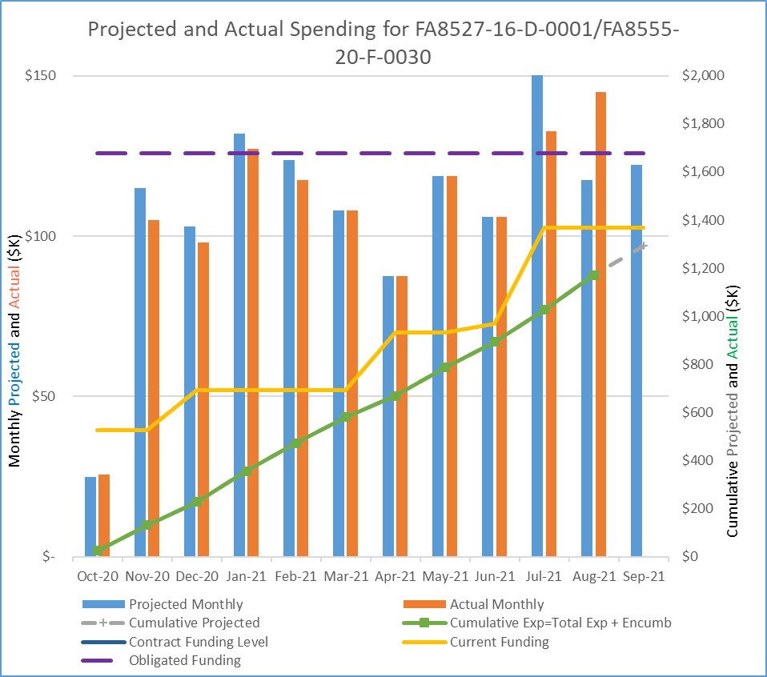

|  |  |  |  |
| --- | --- | --- | --- |
| Task Title | Engineering Labor  Category | Number of Individuals | Current Month Total Hours |
| ALL Total | Principal Research Engineer | 2 | 20 |
| Principal Research Scientist | 1 | 48.5 |
| Senior Research Engineer | 4 | 215 |
| Research Engineer II | 1 | 74 |
| Research Engineer I | 3 | 469.9 |
| Grand Total |  | **11** | **827.4** |